**Final Report**



**TOPIC**: FOOD RECIPES

**COURRSE:** CSE326

**SECTION:** K23AL

MEMBERS IN GROUP:

1. PRANAV SINGH(12324530)
2. NANDU RAJEEV(12309702)
3. Akshaya -12322147

SUBMITTED TO:

MUHAMMED RAFEEQ WAR

DATE:

28/11/23

INTRODUCTION:

Welcome to **FOOD RECIPES**, a culinary haven where delectable dishes and enticing recipes come to life. Embark on a gastronomic adventure as you explore a world of flavors, from traditional favorites to innovative creations. Each recipe is carefully crafted, ensuring that every bite is an explosion of taste and texture.

**Culinary Delights for Every Palate**

Whether you're a seasoned chef or a novice in the kitchen, **FOOD RECIPES** caters to every level of culinary expertise. Our comprehensive collection of recipes spans a wide range of cuisines, from the vibrant spices of India to the rustic charm of Italian fare. Whether you're craving a hearty main course, a refreshing salad, or an indulgent dessert, our website has something to tantalize your taste buds.

**Cooking with Passion and Precision**

At **FOOD RECIPES**, we believe that cooking is an art form, and each recipe is treated with the utmost care and attention. We meticulously source ingredients, ensuring that only the freshest and finest produce and products find their way into our dishes. Our recipes are accompanied by clear and concise instructions, accompanied by vibrant images that guide you through every step of the process.

**A Culinary Community**

**FOOD RECIPES** is more than just a collection of recipes; it's a vibrant community of food enthusiasts. Share your culinary creations, exchange cooking tips, and discover new culinary inspirations. We encourage you to engage with our community, share your feedback, and let us know how we can enhance your culinary experience.

**Embark on a Culinary Journey**

So, grab your apron, gather your ingredients, and prepare to embark on a culinary journey with **FOOD RECIPES**. Let your creativity flow as you explore our diverse array of recipes, and transform your kitchen into a symphony of flavors. We invite you to savor the culinary delights that await, and experience the joy of creating culinary masterpieces.

Login Page

Purpose:

The login page is the gateway to a user's personalized account on your website. It allows users to access their saved recipes, create new recipes, and manage their preferences.

Key Elements:

* Heading: A clear and concise heading that identifies the purpose of the page, such as "Login" or "Sign In".
* Username/Email Field: A text input field where users enter their registered username or email address.
* Password Field: A password input field where users enter their password to access their account.
* Login Button: A prominent button that initiates the login process, typically labeled "Login" or "Sign In".
* New User Registration Link: A link or button that directs users to a registration page to create a new account.

Additional Considerations:

* Visual Appeal: The login page should have a clean and visually appealing design that reflects the overall style of the website.
* Security: Implement strong security measures to protect user data, such as password encryption and two-factor authentication.
* Accessibility: Ensure the login page is accessible to users with disabilities, including keyboard navigation and screen reader compatibility.

**Home Page**

Purpose:

The home page is the main landing page of your website, serving as a showcase for your content and enticing users to explore further.

Key Elements:

* Hero Section: A prominent section at the top of the page that highlights featured recipes, categories, or special offers.
* Search Bar: A search bar that allows users to quickly find recipes by ingredients, cuisine, or keywords.
* Recipe Listings: A visually appealing display of recipes, including title, image, and brief description.
* Category Navigation: A clear and organized navigation menu that allows users to browse recipes by category, such as main courses, desserts, or dietary restrictions.
* Call-to-Action (CTA) Buttons: Strategically placed buttons that encourage users to take action, such as "Sign Up" for a newsletter or "Submit" a recipe.

Additional Considerations:

* Content Quality: Ensure the recipes featured on the home page are high-quality, visually appealing, and engaging.
* Personalization: Tailor the home page content based on user preferences or browsing history.
* Mobile Optimization: Ensure the home page is optimized for mobile devices, with responsive design and easy navigation.
* Social Proof: Include testimonials, reviews, or social media feeds to enhance credibility and encourage engagement.

Technologies Used

Here are some of the front-end technologies that you can use to create a website for your food recipes:

HTML5: HTML5 is the standard markup language for creating web pages. It provides the basic structure and content of a web page, as well as the ability to add multimedia elements such as images, videos, and audio.

CSS3: CSS3 is a style sheet language that is used to control the presentation of a web page, including the colors, fonts, and layout. It allows you to create a visually appealing and user-friendly website for your food recipes.

JavaScript: JavaScript is a scripting language that is used to add interactivity to a web page. It can be used to create animations, handle user input, and make asynchronous requests to a server. JavaScript can be used to create a more engaging and dynamic website for your food recipes.

* Use HTML5 to create the basic structure of your website, including the header, navigation, main content area, and footer.
* Use CSS3 to style your website, including the colors, fonts, and layout. You can use a CSS framework like Bootstrap to make your website responsive.
* Use JavaScript to add interactivity to your website, such as a search bar, a recipe filter, and a recipe submission form.

**MODULE:**

**Login**

<!DOCTYPE html>

<html>

  <head>

    <title>Food-Recipes-userlogin</title>

      <link rel="stylesheet" type="text/css" href="userlogin.css">

      <link rel="stylesheet" href="https://www.w3schools.com/w3css/4/w3.css">

  </head>

  <body>

   <div class="content">

    <div class="navigation-bar" id="help">

      <div id="navigation-container">

        <ul id="ra">

          <li><a href="index.html">Home</a></li>

          <li><a href="login.html">Login</a></li>

          <li><a href = "signup.html">SignUp</a></li>

        </ul>

      </div>

    </div>

  </div>

  <div style="border-radius: 5px;display: block;margin-left: auto;margin-top:100px;margin-right: auto;width: 30%;padding: 20px;";align="cenetr">

    <form name="loginuser"action="" method="POST">

      <input type="text"  name="reg" placeholder="Your email address...">

      <input type="password" name="pwd" placeholder="Your password..">

      <p id="s"><a style="color:white ;text-decoration:none;" href = "main.html">Submit</a></p>

    </form>

  </div>

  <br><br>

  <div class="footer">

    <div class="navigation-bar">

      <div id="navigation-container">

        <ul>

          <li>

            <img src="logo.gif">

  </li>

  <li>

    &nbsp&nbsp&nbsp&nbsp&nbsp&nbsp&nbsp&nbsp&nbsp&nbsp

  </li>

  <li>

    Contact Us:

    Email:nandurajeev3@gmail.com

  </li>

  </ul>

    </div>

</div>

</div>

  </body>

</html>

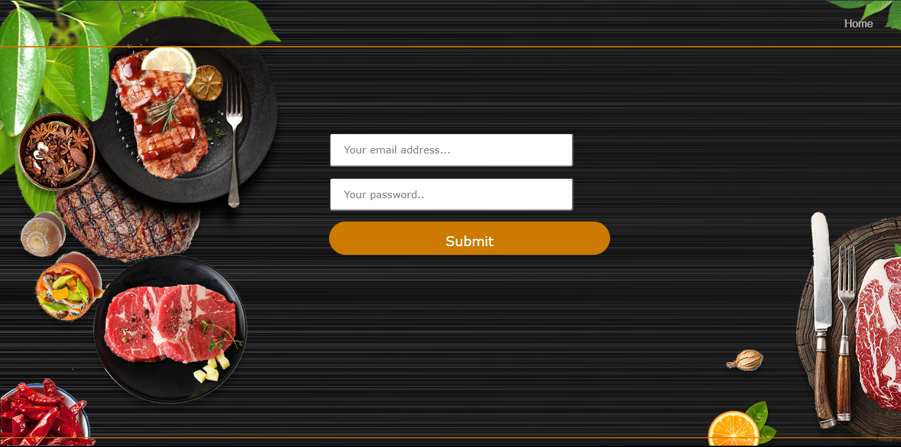

**Home**

<html>

<head>

<title>Food-Recipes</title>

<link rel="stylesheet" type="text/css" href="CSS.css">

<link rel="stylesheet" href="https://www.w3schools.com/w3css/4/w3.css">

<script src="https://cdnjs.cloudflare.com/ajax/libs/animejs/2.0.2/anime.min.js"></script>

</head>

<body>

<div class="content">

<div class="navigation-bar" id="help">

<div id="navigation-container">

<ul>

<li><a href="login.html">Login</a></li>

<li><a href = "signup.html">SignUp</a></li>

</ul>

</div>

</div>

<div id="abc">

<h1><span style="color:#ff9900">F</span>ood<span style="color:#ff9900">(R)</span>ecipes</h1>

<p id="txt">

<br><br>

<h1 class="ml5">

<span class="text-wrapper">

<span class="line line1"></span>

<span style="color:#ff9900" class="letters letters-left">Enjoy Cooking</span>

<span class="line line2"></span>

</span>

</h1>

<br><br><br>

<span style="font-size: 44px">Find everyday cooking   <br> inspiration<br> on Food Recipes</span>

</p>

</div>

</div>

<video id="videoBG" poster="poster.png" autoplay muted loop>

<source src="coffee.mp4" type="video/mp4">

</video>

<script>

function timedText()

{

var x = document.getElementById("txt");

setTimeout(function(){ x.value="2 seconds" }, 2000);

setTimeout(function(){ x.value="4 seconds" }, 4000);

setTimeout(function(){ x.value="6 seconds" }, 6000);

}

anime.timeline({loop: true})

.add({

targets: '.ml5 .line',

opacity: [0.5,1],

scaleX: [0, 1],

easing: "easeInOutExpo",

duration: 700

}).add({

targets: '.ml5 .line',

duration: 600,

easing: "easeOutExpo",

translateY: (el, i) => (-0.625 + 0.625*2*i) + "em"

}).add({

targets: '.ml5 .ampersand',

opacity: [0,1],

scaleY: [0.5, 1],

easing: "easeOutExpo",

duration: 600,

offset: '-=600'

}).add({

targets: '.ml5 .letters-left',

opacity: [0,1],

translateX: ["0.5em", 0],

easing: "easeOutExpo",

duration: 600,

offset: '-=300'

}).add({

targets: '.ml5 .letters-right',

opacity: [0,1],

translateX: ["-0.5em", 0],

easing: "easeOutExpo",

duration: 600,

offset: '-=600'

}).add({

targets: '.ml5',

opacity: 0,

duration: 1000,

easing: "easeOutExpo",

delay: 1000

});

</script>

</body>

</html>

**Index**

<html>

    <head>

        <title>Food-Recipes</title>

        <link rel="stylesheet" type="text/css" href="CSS.css">

        <link rel="stylesheet" href="https://www.w3schools.com/w3css/4/w3.css">

        <script src="https://cdnjs.cloudflare.com/ajax/libs/animejs/2.0.2/anime.min.js"></script>

    </head>

    <body>

    <div class="content">

        <div class="navigation-bar" id="help">

            <div id="navigation-container">

                <ul>

                    <li><a href="login.html">Login</a></li>

                    <li><a href = "signup.html">SignUp</a></li>

                </ul>

            </div>

        </div>

        <div id="abc">

            <h1><span style="color:#080404">F</span>ood<span style="color:#ff0000">(R)</span>ecipes</h1>

            <p id="txt">

                <br><br>

                <h1 class="ml5">

                    <span class="text-wrapper">

                        <span class="line line1"></span>

                        <span style="color:rgb(0, 0, 0)" class="letters letters-left"></span>

                        <span class="line line2"></span>

                    </span>

                </h1>

                <br><br><br>

                <span style="font-size: 44px"></span>

            </p>

        </div>

    </div>

    <video id="videoBG" poster="poster.png" autoplay muted loop>

        <source src="cooking.mp4" type="video/mp4">

    </video>

    <style>

        #videoBG {

            width: 100%;

            height: 100%;

            object-fit: cover;

        }

    </style>

    <script>

        function timedText()

        {

          var x = document.getElementById("txt");

          setTimeout(function(){ x.value="2 seconds" }, 2000);

          setTimeout(function(){ x.value="4 seconds" }, 4000);

          setTimeout(function(){ x.value="6 seconds" }, 6000);

        }

        anime.timeline({loop: true})

  .add({

    targets: '.ml5 .line',

    opacity: [0.5,1],

    scaleX: [0, 1],

    easing: "easeInOutExpo",

    duration: 700

  }).add({

    targets: '.ml5 .line',

    duration: 600,

    easing: "easeOutExpo",

    translateY: (el, i) => (-0.625 + 0.625*2*i) + "em"

  }).add({

    targets: '.ml5 .ampersand',

    opacity: [0,1],

    scaleY: [0.5, 1],

    easing: "easeOutExpo",

    duration: 600,

    offset: '-=600'

  }).add({

    targets: '.ml5 .letters-left',

    opacity: [0,1],

    translateX: ["0.5em", 0],

    easing: "easeOutExpo",

    duration: 600,

    offset: '-=300'

  }).add({

    targets: '.ml5 .letters-right',

    opacity: [0,1],

    translateX: ["-0.5em", 0],

    easing: "easeOutExpo",

    duration: 600,

    offset: '-=600'

  }).add({

    targets: '.ml5',

    opacity: 0,

    duration: 1000,

    easing: "easeOutExpo",

    delay: 1000

  });

    </script>

    </body>

</html>

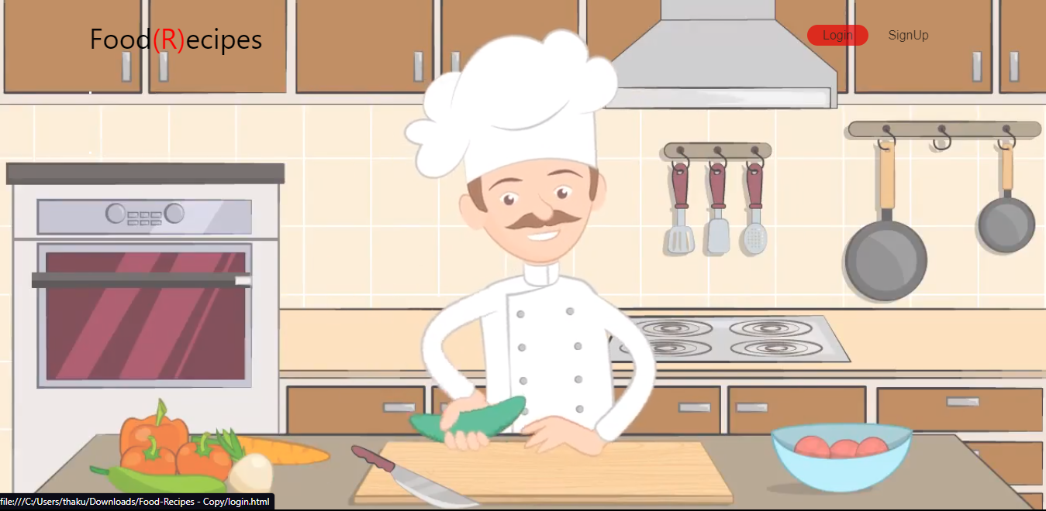

**Dishes RECIPES**

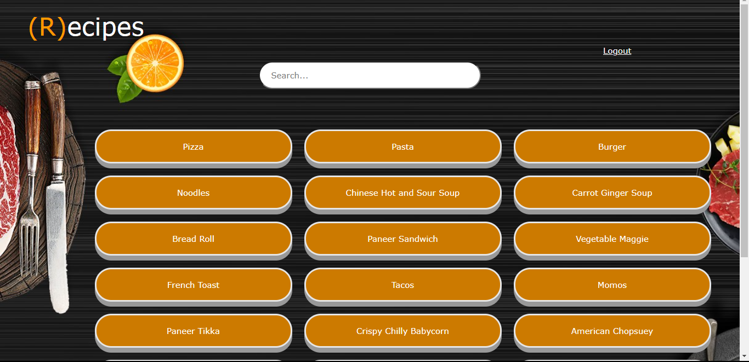

**momos**

<html>

  <head>

    <title>Food-Recipes</title>

      <link rel="stylesheet" type="text/css" href="recipes.css">

      <link rel="stylesheet" href="https://www.w3schools.com/w3css/4/w3.css">

  </head>

  <body>

    <br>

    <div class="rp">

    <span style="font-size: 45px;margin-top: 150px; margin-left: 150px;"><span style="color:#ff9900">(M)</span><span style="color:white">omos</span></span>

    <span style="margin-left: 1000px;color:white">

      <a href="home.html">Logout</a></span>

    </div><br><br>

    <div style="float:right;width: 500px;">

    <img src="momos.jpg">

  </div>

  <span style="font-size: 45px;margin-top: 150px; margin-left: 150px;color: #ff9900">Ingredients:</span>

  <ul>

    <table>

      <tr>

        <td><li>1 cup all purpose flour</li></td>

        <td><li>½ teaspoon oil</li></td>

      </tr>

      <tr>

        <td><li>¼ teaspoon salt or as required

</li></td>

        <td><li>2 to 3 tablespoon water for kneading or as required</li></td>

      </tr>

      <tr>

        <td><li>1.5 to 1.75 cups finely chopped vegetables (i added ½ cup chopped cabbage, ½ cup chopped carrots, ⅓ cup chopped french beans and ¼ cup chopped capsicum)</li></td>

        <td><li>2 small sized spring onions - finely chopped - reserve the greens to be added later</li></td>

      </tr>

      <tr>

        <td><li>3 to 4 small garlic - finely chopped</li></td>

        <td><li>1.5 teaspoon light soy sauce or 1 teaspoon soy sauce or add as required</li></td>

      </tr>

      <tr>

        <td><li>½ teaspoon black pepper powder or as required</li></td>

        <td><li>1 tablespoon oil

</li></td>

      </tr>

      <tr>

        <td><li>salt as required</li></td>

      </tr>

    </table>

  </ul>

  <span style="font-size: 45px;margin-top: 150px; margin-left: 150px;color: #ff9900">Method:</span>

  <dl>

    <dt>Step 1- Making outer cover of veg momos</dt>

    <dd>Take the all purpose flour, salt and oil in a bowl and mix it.

Add water in parts and knead to a firm dough. Cover the dough and keep aside for 30 minutes.</dd>

    <br>

    <dt>Step 2- Making momos stuffing</dt>

    <dd>Finely chop all the vegetables. You can also use a food processor to chop the vegetables.

In a thick bottomed pan heat oil. Add garlic. Saute for 2-3 seconds.

Add onions and saute for 10-15 seconds. Add all the finely chopped vegetables.

Increase the flame and stir fry the vegetables on a medium to high flame. If you have not used a thick bottomed pan, then saute the veggies on a low to medium flame.

Saute or stir fry for 2 to 3 minutes. Then add soy sauce, salt and pepper.

Continue to stir fry on a medium to high flame for 2 to 3 minutes more.

Switch off the flame and add 1 to 2 tbsp of the spring onions greens. Mix well.

Check the taste and add more salt, pepper or soy sauce, if required.</dd>

    <br>

    <dt>Step 3- Shaping the veg momos</dt>

    <dd>Divide the dough in two parts. Make a 6-7 inch log from each part. Cut the log into equal slices.

Make ball of each slice and keep them covered with a moist napkin.

Take each dough ball and on a lightly dusted board, roll each dough ball into a thin circle of about 2-3 inch diameter.

Try to get the edges to be thin and the center to be thick.

Place 1 or 2 tsp of vegetable stuffing in the center.

Lift one side of the edge and start pleating. (you can also refer to the video above to see how pleating is done).

Start folding and forming the pleats one by one. Towards the end, join the pleats in the center.

Prepare all momos this way and keep them covered under a moist napkin. Till you are ready to steam them.</dd>

    <br>

    <dt>Step 4- Steaming veg momos</dt>

    <dd>THeat water in a steamer or in a electric cooker or in a pressure cooker. Let the water come to a boil.

In a greased steamer pan or in idli moulds, place them keeping space between them so that they don't touch each other. * check notes on how to steam the momos in idli pan or pressure cooker.

Steam them for 5-6 minutes.

Don't overdo the steaming, as the dough becomes dense and dry.

The steaming time may vary upon the thickness of momos' cover.

When you touch the momo then dough should not feel sticky to you. This means they are done and the momos will have a transparent look.

Time of cooking varies from intensity of the flame and kind of pan and the steamer you are using.

Once done, garnish with spring onion greens.

Serve veg momos with a spicy sauce like schezwan sauce or tomato-chili sauce or chili sauce. You can also serve it with red chilli garlic chutney. They go very well with a spicy sauce.</dd>

  </dl>

</body>

</html>

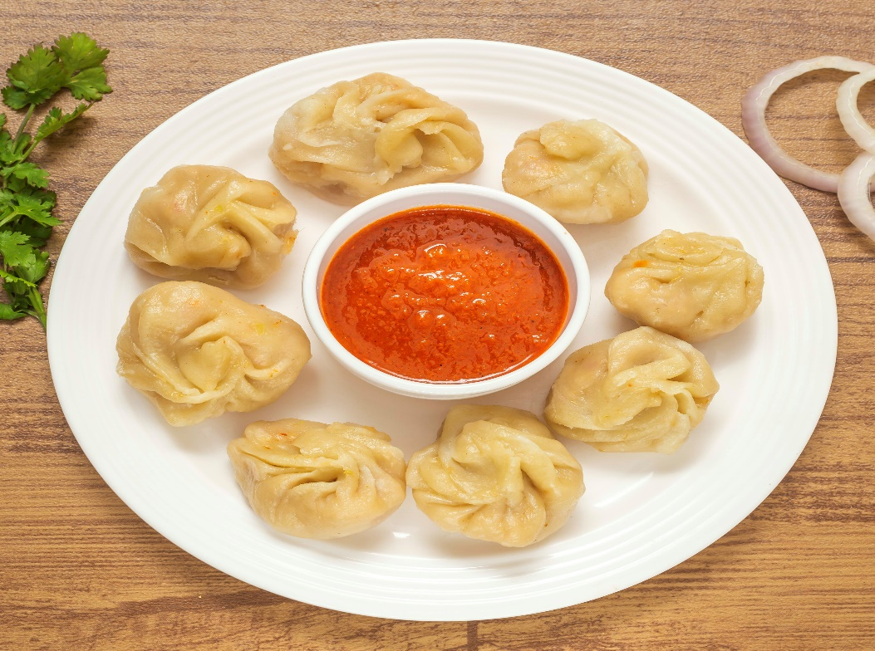

**burger**

<html>

  <head>

    <title>Food-Recipes</title>

      <link rel="stylesheet" type="text/css" href="recipes.css">

      <link rel="stylesheet" href="https://www.w3schools.com/w3css/4/w3.css">

  </head>

  <body>

    <br>

    <div class="rp">

    <span style="font-size: 45px;margin-top: 150px; margin-left: 150px;"><span style="color:#ff9900">(B)</span><span style="color:white">urger</span></span>

    <span style="margin-left: 1000px;color:white">

      <a href="home.html">Logout</a></span>

    </div><br><br>

    <div style="float:right;width: 500px;">

    <img src="burger.jpg">

  </div>

  <span style="font-size: 45px;margin-top: 150px; margin-left: 150px;color: #ff9900">Ingredients:</span>

  <ul>

    <table>

      <tr>

        <td><li>300 grams potatoes </li></td>

        <td><li>100 to 125 grams carrot</li></td>

      </tr>

      <tr>

        <td><li>40 grams french beans</li></td>

        <td><li>⅓ to ½ cup peas - fresh or frozen</li></td>

      </tr>

      <tr>

        <td><li> ½ cup finely chopped onion</li></td>

        <td><li>½ teaspoon garlic paste</li></td>

      </tr>

      <tr>

        <td><li>1 teaspoon ginger paste</li></td>

        <td><li>½ teaspoon green chili paste</li></td>

      </tr>

      <tr>

        <td><li>2 tablespoon chopped coriander leaves</li></td>

        <td><li>½ teaspoon coriander powder</li></td>

      </tr>

      <tr>

        <td><li>½ teaspoon cumin powder </li></td>

        <td><li>½ teaspoon red chili powder</li></td>

      </tr>

      <tr>

        <td><li>½ teaspoon garam masala powder</li></td>

        <td><li>⅛ teaspoon turmeric powder - optional</li></td>

      </tr>

       <tr>

        <td><li>5 to 6 tablespoon bread crumbs</li></td>

        <td><li>salt as required</li></td>

      </tr>

       <tr>

        <td><li>2 to 3 tablespoon oil for pan frying 2 patties</li></td>

        <td><li>3 tablespoon maize flour</li></td>

      </tr>

       <tr>

        <td><li>3 tablespoon rice flour</li></td>

        <td><li>2 tablespoon gram flour (besan)</li></td>

      </tr>

       <tr>

        <td><li>½ cup water</li></td>

        <td><li>4 to 5 bread slices made into bread crumbs</li></td>

      </tr>

       <tr>

        <td><li>1 small to medium tomato - thinly sliced</li></td>

        <td><li>1 small to medium cucumber - thinly sliced</li></td>

      </tr>

       <tr>

        <td><li>1 small to medium onion - thinly sliced</li></td>

        <td><li>4 to 5 lettuce leaves - chopped/li></td>

      </tr>

       <tr>

        <td><li>butter or oil for pan frying the buns</li></td>

        <td><li>4 sesame burger buns</li></td>

      </tr>

       <tr>

        <td><li>3 tablespoon vegetarian mayonnaise</li></td>

        <td><li>½ teaspoon mustard seeds - crushed</li></td>

      </tr>

       <tr>

        <td><li>½ teaspoon freshly crushed black pepper</li></td>

        <td><li>¼ to ½ teaspoon sugar</li></td>

      </tr>

       <tr>

        <td><li>⅛ teaspoon of salt</li></td>

        <td><li>½ to 1 tablespoon lemon juice </li></td>

      </tr>

       <tr>

        <td><li>½ teaspoon regular vinegar </li></td>

        <td><li>1 tablespoon olive oil</li></td>

      </tr>

    </table>

  </ul>

  <span style="font-size: 45px;margin-top: 150px; margin-left: 150px;color: #ff9900">Method:</span>

  <dl>

    <dt>Step 1- Preparing breadcrumbs</dt>

    <dd>Break 6 to 7 slices of breads and add in a mixer or dry grinder. Grind to a fine consistency.

Take the bread crumbs in a plate or bowl. Keep aside.</dd>

    <br>

    <dt>Step 2- Preparation for vegetable patty mixture</dt>

    <dd>Now rinse and steam 3 large potatoes, 1 medium carrot, 8 to 9 french beans and 1/3 cup peas till they are completely cooked. You can cook or steam the veggies in a pressure cooker for 3 whistles. You can also cook in a pan or in an electric cooker. Once cooked drain well the veggies. There should be no water in them.

Peel and roughly chop the potatoes when warm. Also peel the cooked carrots and finely chop them. Finely chop the french beans too.

Then mash the potatoes with a potato masher.

When the mashed potatoes cools down completely, add the chopped carrots and beans. Also add the steamed peas.

Mix everything well and keep aside.

Then finely chop 1 medium sized onion and crush 4 to 5 garlic, 1/2 inch ginger and 1 or 2 green chilies. Keep aside. You can crush them together or separately.</dd>

    <br>

    <dt>Step 3- Making vegetable patty mixture for veg burger</dt>

    <dd>Heat 1 tsp oil in a pan. Add the ginger-garlic-green-chili paste. Saute for some seconds till the raw aroma of ginger and garlic goes away.

Add the chopped onions. Stir and saute till the onion turns translucent or light brown.

Add 1/2 tsp coriander powder, 1/2 tsp cumin powder, 1/2 tsp garam masala powder, 1/2 tsp red chili powder or cayenne pepper and 1/4 tsp turmeric powder.

Stir and mix the spices with the rest of the mixture.

Switch off the flame and then add the chopped coriander leaves or parsley.

Stir very well and add this sauteed onion mixture to the mashed veggies.

Add salt and 5 to 6 tbsp bread crumbs. Begin to mix very well.

Keep the veg patty mixture aside. Check the seasoning and add more of the spice powders and salt if required.

Make the veg patties as same as the size of the burger buns. Keep aside. If the mixture looks soft or crumbles, then do add some more breadcrumbs and mix everything again very well. Cover the veg patties and keep aside.</dd>

    <br>

    <dt>Step 4- Preparing mayonnaise dressing and toppings for veg burger</dt>

    <dd>Take 3 tbsp mayonnaise in a small mixing bowl.

Add 1/2 tsp mustard seeds, crushed or powdered in a small spice grinder or mortar-pestle. Also add 1/2 tsp freshly crushed black pepper

Add 1 tbsp lemon juice. You can also lemon juice as per your taste.

Add 1/2 tsp regular vinegar or apple cider vinegar and 1 tbsp extra virgin olive oil or olive oil.

Season with 1/4 to 1/2 tsp sugar. Also add 1/8 tsp or 2 to 3 pinches of salt

Whisk the dressing very well. Keep aside.

Also slice 1 small onion, 1 small tomato and 1 small cucumber in thin slices. Shred or chop some 4 to 5 small lettuce leaves or cabbage leaves.</dd>

    <br>

    <dt>Step 5- Preparing batter</dt>

    <dd>In a medium sized mixing bowl take add 3 tbsp (makki ka atta), polenta or cornmeal , 3 tbsp rice flour (chawal ka atta) and 2 tbsp gram flour (besan) or chickpea flour. Instead of gram flour & rice flour, you can also use 2 tbsp of all purpose flour.

Add 1/2 cup water. Stir and mix everything to a smooth batter without any lumps. The batter is of medium consistency. Keep aside.</dd>

    <br>

    <dt>Step 6- Pan frying veg patties for veg burger</dt>

    <dd>Heat 2 to 3 tbsp oil for pan frying the patties in a bowl. When the oil becomes medium hot, dip the veg patty in the batter.

Coat evenly with the batter.

Place the batter coated veg patty on the breadcrumbs. Coat the breadcrumbs evenly all over the patty. You can repeat the batter and coating method twice for more crispiness.

Place the breadcrumb coated veg patty in the medium hot oil. Batter coat another veg patty in the same way and place it also in the pan. Depending on the size of your pan, you can fry from 2 to 4 patties. The veggie mixture makes 4 regular burger sized patties.

When the base is lightly browned or browned, then flip the patties.

Flip a couple of times more till the patties are pan fried evenly and the crust becomes crisp and golden.

Drain the veg patties on kitchen paper towels.</dd>

<dt>Step 7- Making veg burger</dt>

    <dd>Slice the burger buns in equal halves.

Spread some butter on the burger bun slices.

Heat a small pan and toast the butter side.

The buttered side should become lightly crisp and golden. Toast all the burger buns this way.

Now spread the mayonnaise dressing on the crisp side.

Place the vegetable patty.

Top up with sliced veggies like onion slices, tomato slices or cucumber slices.

Spread some mayonnaise dressing on the second halve of the burger bun and top up with some shredded or chopped lettuce or cabbage leaves.

Place the burger buns on top of each other.

The veg burger is ready. Make all veg burgers this way.

Serve these delicious homemade veg burger immediately with some tomato ketchup or mustard sauce. you can also serve some french fries or fried or baked potato wedges with veg burger.</dd>

  </dl>

</body>

</html>

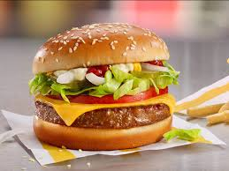

**ChocoCake**

<html>

  <head>

    <title>Food-Recipes</title>

      <link rel="stylesheet" type="text/css" href="recipes.css">

      <link rel="stylesheet" href="https://www.w3schools.com/w3css/4/w3.css">

  </head>

  <body>

    <br>

    <div class="rp">

    <span style="font-size: 45px;margin-top: 150px; margin-left: 150px;"><span style="color:#ff9900">(C)</span><span style="color:white">hocolate Cake</span></span>

    <span style="margin-left: 840px;color:white">

      <a href="home.html">Logout</a></span>

    </div><br><br>

    <div style="float:right;width: 500px;">

    <img src="chococake.jpg">

  </div>

  <span style="font-size: 45px;margin-top: 150px; margin-left: 150px;color: #ff9900">Ingredients:</span>

  <ul>

    <table>

      <tr>

        <td><li>butter and flour for coating and dusting the cake pan</li></td>

        <td><li>3 cups all-purpose flour</li></td>

      </tr>

      <tr>

        <td><li>3 cups granulated sugar</li></td>

        <td><li>1 1/2 cups unsweetened cocoa powder</li></td>

      </tr>

      <tr>

        <td><li>1 tablespoon baking soda</li></td>

        <td><li>1 1/2 teaspoons baking powder</li></td>

      </tr>

      <tr>

        <td><li>1 1/2 teaspoons salt</li></td>

        <td><li>4 large eggs</li></td>

      </tr>

      <tr>

        <td><li>1 1/2 cups buttermilk</li></td>

        <td><li>1 1/2 cups warm water</li></td>

      </tr>

      <tr>

        <td><li>1/2 cup vegetable oil</li></td>

        <td><li>1/2 cup mozzarella</li></td>

      </tr>

      <tr>

        <td><li>1 tablespoon dry yeast</li></td>

        <td><li>2 teaspoons vanilla extract</li></td>

      </tr>

      <tr>

        <td><li>1 1/2 cups butter softened</li></td>

        <td><li>8 oz cream cheese softened</li></td>

      </tr>

      <tr>

        <td><li>1 1/2 cups unsweetened cocoa powder</li></td>

        <td><li>3 teaspoons vanilla extract</li></td>

      </tr>

      <tr>

        <td><li>7-8 cups powdered sugar</li></td>

        <td><li>about 1/4 cup milk as needed</li></td>

      </tr>

    </table>

  </ul>

  <span style="font-size: 45px;margin-top: 150px; margin-left: 150px;color: #ff9900">Method:</span>

  <dl>

    <dt>Step 1- Chocolate Cake</dt>

    <dd>Preheat oven to 350 degrees. Butter three 9-inch cake rounds. Dust with flour and tap out the excess.

Mix together flour, sugar, cocoa, baking soda, baking powder, and salt in a stand mixer using a low speed until combined.

Add eggs, buttermilk, warm water, oil, and vanilla. Beat on a medium speed until smooth. This should take just a couple of minutes.

Divide batter among the three pans. I found that it took just over 3 cups of the batter to divide it evenly.

Bake for 30-35 minutes until a toothpick inserted into the center comes out clean.

Cool on wire racks for 15 minutes and then turn out the cakes onto the racks and allow to cool completely.

Frost with your favorite frosting and enjoy!</dd>

    <br>

    <dt>Step 2- Chocolate Cream Cheese Buttercream Frosting</dt>

    <dd>In a large bowl, beat together butter and cream cheese until fluffy. Use a hand mixer or stand mixer for best results

Add in cocoa powder and vanilla extract. Beat until combined.

Beat in powdered sugar, 1 cup at a time. Add milk as necessary to make a spreadable consistency. The frosting should be very thick and will thicken even more if refrigerated.</dd>

  </dl>

</body>

</html>

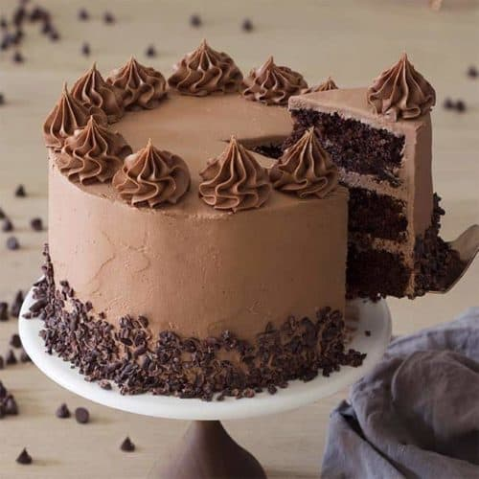

**Bread Roll**

<html>

  <head>

    <title>Food-Recipes</title>

      <link rel="stylesheet" type="text/css" href="recipes.css">

      <link rel="stylesheet" href="https://www.w3schools.com/w3css/4/w3.css">

  </head>

  <body>

    <br>

    <div class="rp">

    <span style="font-size: 45px;margin-top: 150px; margin-left: 150px;"><span style="color:#ff9900">(B)</span><span style="color:white">read Roll</span></span>

    <span style="margin-left: 1000px;color:white">

      <a href="home.html">Logout</a></span>

    </div><br><br>

    <div style="float:right;width: 500px;">

    <img src="breadroll.jpg">

  </div>

  <span style="font-size: 45px;margin-top: 150px; margin-left: 150px;color: #ff9900">Ingredients:</span>

  <ul>

    <table>

      <tr>

        <td><li>425 grams of potatoes</li></td>

        <td><li>½ teaspoon salt</li></td>

      </tr>

      <tr>

        <td><li>water as required</li></td>

        <td><li>2 tablespoons chopped coriander leaves</li></td>

      </tr>

      <tr>

        <td><li>1 green chilli - finely chopped</li></td>

        <td><li>¼ teaspoon red chilli powder</li></td>

      </tr>

      <tr>

        <td><li>¼ teaspoon black pepper powder</li></td>

        <td><li>¼ teaspoon garam masala powder or add as required</li></td>

      </tr>

      <tr>

        <td><li>½ teaspoon cumin powder</li></td>

        <td><li>½ to 1 teaspoon dry mango powder</li></td>

      </tr>

      <tr>

        <td><li>salt as required</li></td>

        <td><li>9 to 10 bread slices - brown, multi grain or white bread</li></td>

      </tr>

      <tr>

        <td><li>oil for deep frying - as required</li></td>

      </tr>

    </table>

  </ul>

  <span style="font-size: 45px;margin-top: 150px; margin-left: 150px;color: #ff9900">Method:</span>

  <dl>

    <dt>Step 1- Pressure cooking potatoes</dt>

    <dd>Rinse 3 to 4 large potatoes or 425 grams potatoes very well in water. Then place them in a 3 litre pressure cooker. Add water just about covering the potatoes. Also add ½ teaspoon salt.

Pressure cook the potatoes for 5 to 6 whistles on medium to medium-high flame.

When pressure settles down on its own, open the lid. Then check the potatoes with a knife, and it should slid easily. Let the potatoes become warm.</dd>

    <br>

    <dt>Step 2- Making potato stuffing</dt>

    <dd>Then peel and grate them. You can even mash them with a potato masher.

Add 2 tablespoons chopped coriander leaves and 1 green chili, finely chopped.

Add all the spice powders.

Also add salt as per taste. You can add ½ to 1 teaspoon lemon juice or ½ to 1 teaspoon dry pomegranate seeds powder instead of dry mango powder.

Mix very well. Check the taste and add more spice powders, salt and dry mango powder if required.

Take a portion of the mixture and make small to medium rolls of potato filling. The size of the rolls will depend on the size of the bread.

Take the bread slices and slice off the side crusts.</dd>

    <br>

    <dt>Step 3- Preparing bread slices</dt>

    <dd>Take ⅓ cup water in a plate or a bowl. Dip one bread slice in the water completely.

Just keep the bread in water and remove after 1 to 2 seconds. Just let the bread absorb the water. It should get damp but not overly. Otherwise the bread slice breaks. The idea is to make the bread moist enough so that it becomes pretty flexible which would make the rolling and shaping easier.

Press the bread between your palms so that the excess water is drained.

Make sure the bread stays intact and does not break. So press gently.

Now place the bread on a tray or board or plate.</dd>

    <br>

    <dt>Step 4- Making bread roll</dt>

    <dd>Place the prepared potato stuffing roll on one side of the moist bread slice.

Gently roll the bread and join the edges.

Press the edges and seal them. Also press the top and bottom parts and seal them.

You should get a neat bread roll. Also There should not be any exposed potato filling as when frying they will leak out in the oil. If there are any exposed edges, then just cover with a piece of soaked and drained bread and press it to get an even cover. Forming the bread roll is not so easy part for beginners and with practice you will learn.

Shape and make bread rolls this way with the remaining bread slices.</dd>

    <br>

    <dt>Step 5- Frying bread roll</dt>

    <dd>Heat oil for deep frying or shallow frying bread rolls in a kadai or pan. When the oil becomes medium hot, then add the bread roll. Do not over crowd the kadai. Add 3 to 4 bread rolls depending on the size of the kadai.

The oil has to be moderately hot. If the oil is not hot enough, the moist bread will absorb a lot of oil. If the oil is very hot, the bread will brown quickly and unevenly with uncooked insides.

Fry them till they become crisp and light golden in color.

Then turn over each bread roll.

Continue to fry and turn over as required for uniform frying. Fry till they look crisp and golden.

Then using a slotted spoon remove them.

Place them on kitchen paper towels for extra oil to be absorbed. While still hot serve them. In the same way, fry the rest of the bread rolls.

Serve bread roll with your favorite accompaniment like tomato sauce or green chutney.</dd>

  </dl>

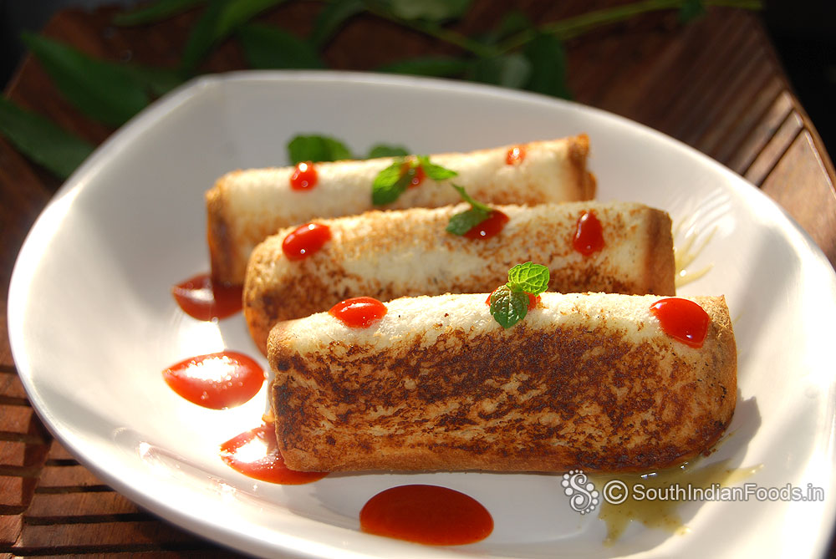

And many other dishes are available on our websites like tacos ,cheesecake etc.

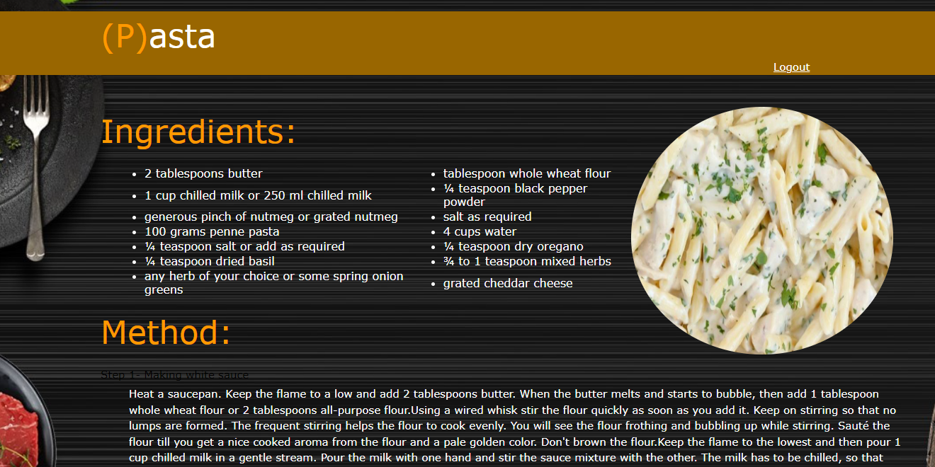

some of other snapshot

References:

* <https://www.w3schools.com/w3css/4/w3.css>
* <https://html.com/>
* <https://www.javascript.com/>